TryHackMe · Tutedude Cybersecurity Track · Task 11
SQL Injection
Automated Blind/Union SQL Injection — Database Enumeration & Data Exfiltration
Platform: TryHackMe Room: tutedude-cybersec Category: SQL Injection
Prepared by: Farhan Date: August 16, 2026
FLAG CAPTURED
Flag{SQLI_EXFILTRATION_SUCCESSFUL}

Objective
This task targets the SecureCorp Portal, a TryHackMe lab application, with the goal of locating and exploiting a SQL Injection vulnerability in the internal employee directory search feature (search.php). The objective is to move from a simple, unsanitized search parameter to full database enumeration and exfiltration of a protected table using automated tooling, culminating in retrieval of the task flag.
Environment & Tools
Target | SecureCorp Portal — http://192.168.155.129/ (TryHackMe lab instance)
Platform | TryHackMe — tutedude-cybersec room
Vulnerable Endpoint | GET /search.php?q=
Tools Used | Burp Suite (Proxy / Repeater), sqlmap v1.10.8, Chromium-based browser
Back-end DBMS | MySQL / MariaDB ≥ 5.6 (confirmed via sqlmap fingerprinting)
Methodology
Step 1 — Authentication & Locating the Search Feature
Using the low-privileged account for user ‘john’ (credentials previously recovered from the login page’s client-side source), the portal was accessed and the Directory section was opened. The page exposes a free-text “Search the internal global directory by employee name” field, backed by search.php, which queries the database directly with the supplied term — an immediate candidate for injection testing given the footer’s disclosure of the back-end stack (MySQL / MariaDB) and a legacy front-end library.
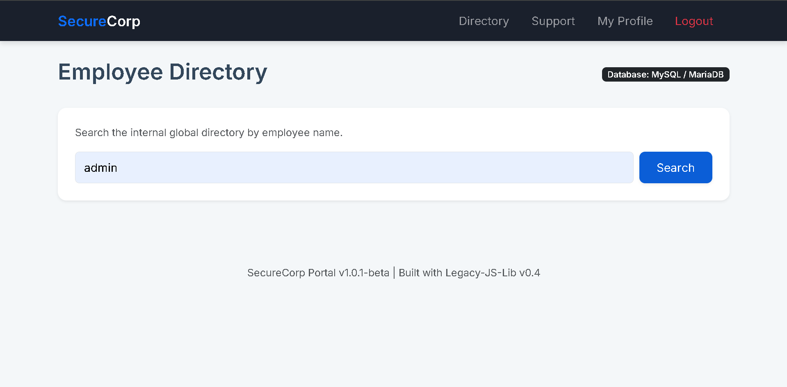
Figure 1 — Employee Directory search page, querying search.php with the term “admin”.
Step 2 — Intercepting the Search Request in Burp Suite
With Burp Suite’s proxy active, the search request was captured. The request confirmed the vulnerable parameter as the GET query string q, submitted alongside the standard PHPSESSID session cookie and a plaintext user_role cookie:
GET /search.php?q=admin* HTTP/1.1
Host: 192.168.155.129
Cookie: PHPSESSID=4ougrdo3o8qro128p6tni899vk; user_role=employee
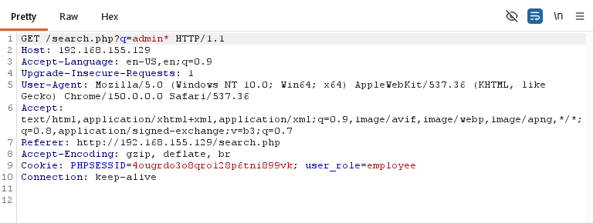
Figure 2 — Burp Suite Proxy: intercepted GET /search.php?q= request used as the injection point.
An asterisk (*) was appended to the search term inside the intercepted request. In sqlmap, an asterisk marks the exact position where injection payloads should be inserted when a request is supplied via the -r (request file) option, rather than relying on sqlmap to auto-detect every parameter.
Step 3 — Exporting the Request for sqlmap
Rather than re-typing the request, the intercepted and marked request was exported directly from Burp Suite as a raw HTTP request file, which sqlmap can consume with the -r flag.
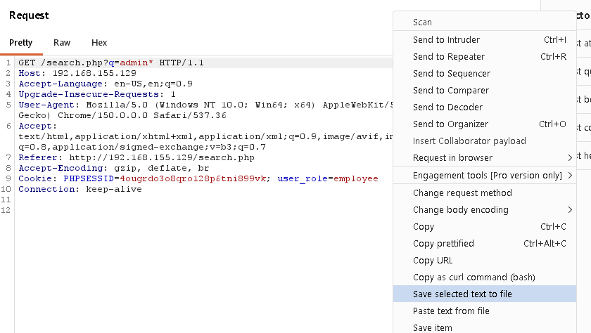
Figure 3 — Burp Suite: ‘Save selected text to file’ used to export the marked request.
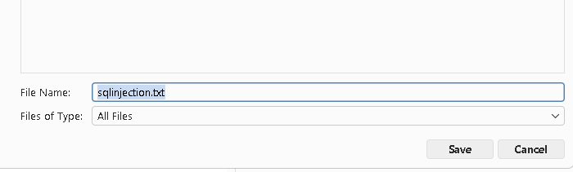
Figure 4 — Request saved locally as sqlinjection.txt for use with sqlmap -r.
Step 4 — Enumerating Available Databases
sqlmap was pointed at the saved request file and run with --dbs to confirm the injection and enumerate all databases visible to the current database user:
sqlmap -r sqlinjection.txt --dbs --random-agent
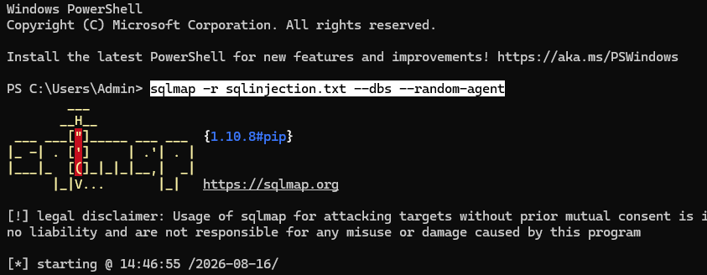
Figure 5 — sqlmap launched against the saved request, using a randomized User-Agent.
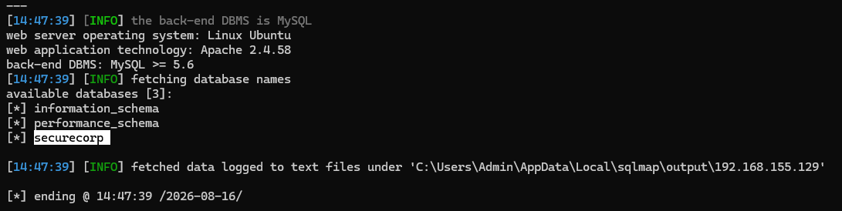
Figure 6 — Back-end confirmed as MySQL on Linux/Apache; three databases enumerated, including securecorp.
sqlmap fingerprinted the back end as MySQL ≥ 5.6 on a Linux Ubuntu host running Apache 2.4.58, and returned three databases: information_schema, performance_schema, and securecorp — the application’s own database and the clear target for further enumeration.
Step 5 — Enumerating Tables in securecorp
With the target database identified, sqlmap was re-run against the same injection point to list its tables:
sqlmap -r sqlinjection.txt -D securecorp --tables --random-agent
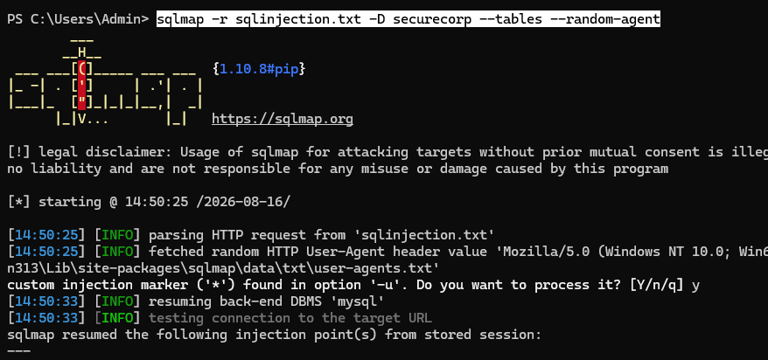
Figure 7 — sqlmap resuming the stored injection session against the securecorp database.
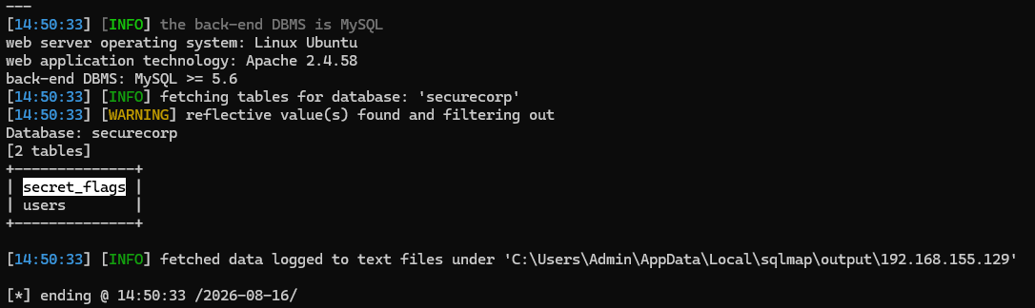
Figure 8 — Two tables recovered: secret_flags and users. secret_flags is the clear target for the task flag.
Step 6 — Dumping the secret_flags Table
The secret_flags table was dumped in full using sqlmap’s -T and --dump options:
sqlmap -r sqlinjection.txt -D securecorp -T secret_flags --dump --random-agent
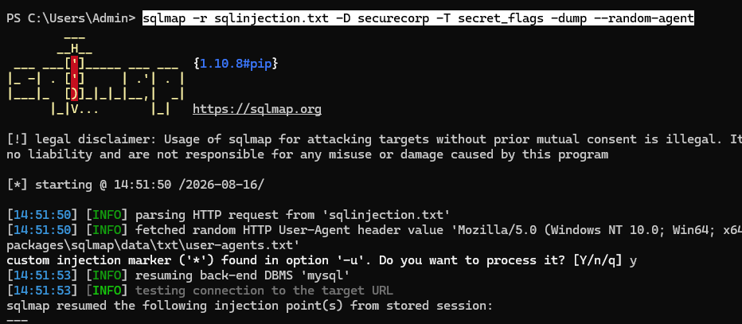
Figure 9 — sqlmap dumping secret_flags, resuming the previously fingerprinted injection point.
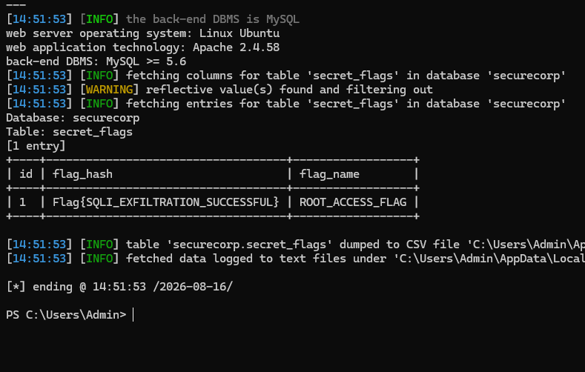
Figure 10 — Dumped contents of secret_flags: a single row containing the task flag in the flag_hash column.
The dump returned one row from secret_flags, containing an id, a flag_name of ROOT_ACCESS_FLAG, and a flag_hash value of Flag{SQLI_EXFILTRATION_SUCCESSFUL} — the objective flag for this task.
Step 7 — Flag Submission & Validation
Figure 11 — Flag{SQLI_EXFILTRATION_SUCCESSFUL} submitted and accepted as the correct answer on TryHackMe.
Vulnerability Analysis
Vulnerability | SQL Injection — unsanitized user input concatenated directly into a back-end SQL query
OWASP Category | A03:2021 — Injection
Weakness (CWE) | CWE-89: Improper Neutralization of Special Elements used in an SQL Command
Severity | Critical — full database read access via automated exploitation, no authentication of the DB layer required beyond a low-privilege app session
The root cause is that search.php passes the q parameter into a SQL query without parameterization, input validation, or output encoding. Because the query string is interpreted as executable SQL rather than as inert data, an attacker-controlled value can alter the query’s logic — enabling boolean-, error-, or UNION-based extraction of arbitrary data from any database and table the application’s database user can read, entirely independent of the role enforced at the application layer.
Impact
- Full read access to the securecorp database, including a dedicated secret_flags table never exposed through any legitimate application feature.
- Automated, low-effort exploitation — a single marked request file and three sqlmap commands were sufficient to enumerate databases, tables, and dump table contents end-to-end.
- The same injection point would equally allow enumeration of the users table, and depending on the database account’s privileges, could extend to reading arbitrary files or other databases on the host.
- Because the flaw sits at the data layer, it bypasses any application-level authorization checks (e.g. role cookies) entirely — a low-privileged employee session was sufficient to reach data with no corresponding UI exposure.
Remediation Recommendations
- Use parameterized queries / prepared statements (or a vetted ORM) for every database call that incorporates user input — never build SQL via string concatenation.
- Apply strict server-side input validation on the search parameter (expected character set, length limits) as defense in depth, not as the primary control.
- Run the application’s database account under the principle of least privilege, so even a successful injection cannot read tables unrelated to the feature being served.
- Remove or strictly limit verbose SQL error output returned to the client, which materially speeds up error-based and blind injection techniques.
- Add a web application firewall (WAF) rule set as a compensating control while the underlying query layer is remediated, and monitor for sqlmap-characteristic request patterns.
- Extend automated security testing (e.g. sqlmap, Burp Scanner) to every user-input endpoint as part of the CI/CD pipeline to catch regressions.
Conclusion
This task demonstrates a textbook SQL Injection vulnerability (OWASP A03:2021): user-supplied input reaching a back-end SQL query without sanitization or parameterization. Marking the injection point in Burp Suite and driving exploitation through sqlmap was sufficient to fingerprint the database, enumerate its schema, and exfiltrate a protected table end-to-end, retrieving Flag{SQLI_EXFILTRATION_SUCCESSFUL}. The exercise reinforces a core secure-coding principle: user input must never be treated as trusted, executable code, and query construction must be handled through parameterization at every layer of the application.

FLAG CAPTURED
Flag{SQLI_EXFILTRATION_SUCCESSFUL}

